How to Be the Boss of Your AI Assistant

Understanding LLMs & The Research Workflow

Michael Borck

# Welcome!

## Today’s Journey

* Understanding your AI assistant
* Why structure beats magic
* A proven 10-step research workflow
* Live demonstration
* **Your roadmap to AI-powered research**

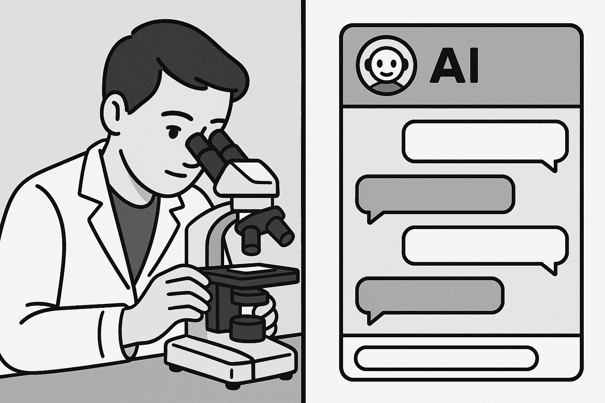

Welcome students. Today we’re learning how to effectively manage AI tools for research. This isn’t about fancy prompts - it’s about understanding how these tools work.

# Quick System Check! 📋

**Do you have access to:**

* ✅ Microsoft Copilot (copilot.microsoft.com)
* ✅ Internet connection
* ✅ Ability to download files

**Can’t Access Copilot?**

* Try ChatGPT (chat.openai.com) - free tier works
* Claude (claude.ai) - also free
* **Key point:** The principles work with ANY AI assistant

**Timing:** We’ll have troubleshooting breaks at 15 and 35 minutes!

# The Problem: The “Everything” Prompt

## Have you ever tried this?

* You ask AI to do a huge task all at once…
* “Analyse high-pressure processing for juice shelf life, tell me pros and cons, design an experiment for Vitamin C in orange juice, write the methods, and create expected results table”

# What do you get back? 😕

* ❌ Shallow, generic summary
* ❌ Forgets half your instructions
* ❌ Messy, unusable output

**Real Example:** “Write my entire literature review on plant proteins” → Gets 2 paragraphs of Wikipedia-level content

This happens because you’re giving the AI too much to think about at once. It’s like asking someone to juggle while solving math problems.

# The Solution: Think Like a Manager 🎯

## Not a Magician! ✨

**Big Idea:** Break complex research into small, logical steps

## The Golden Rule - **One Task, One Prompt**

Give your AI assistant one clear job at a time

**Let’s explore why this simple rule is so powerful…**

# Quick Start Essentials 📸

**The Most Important Prompt Template:**

You are an AI research scientist specializing in [YOUR FIELD].  
  
Task: [ONE SPECIFIC TASK]  
  
Requirements:  
- [SPECIFIC REQUIREMENT 1]  
- [SPECIFIC REQUIREMENT 2]  
- [SPECIFIC REQUIREMENT 3]  
  
Format: [HOW YOU WANT THE OUTPUT]  
  
Context: [BACKGROUND INFO IF NEEDED]

**Save this!** 80% of your AI interactions will use this basic structure

# Reason 1: Limited “Working Memory” 🧠

### ❌ The “Everything” Prompt

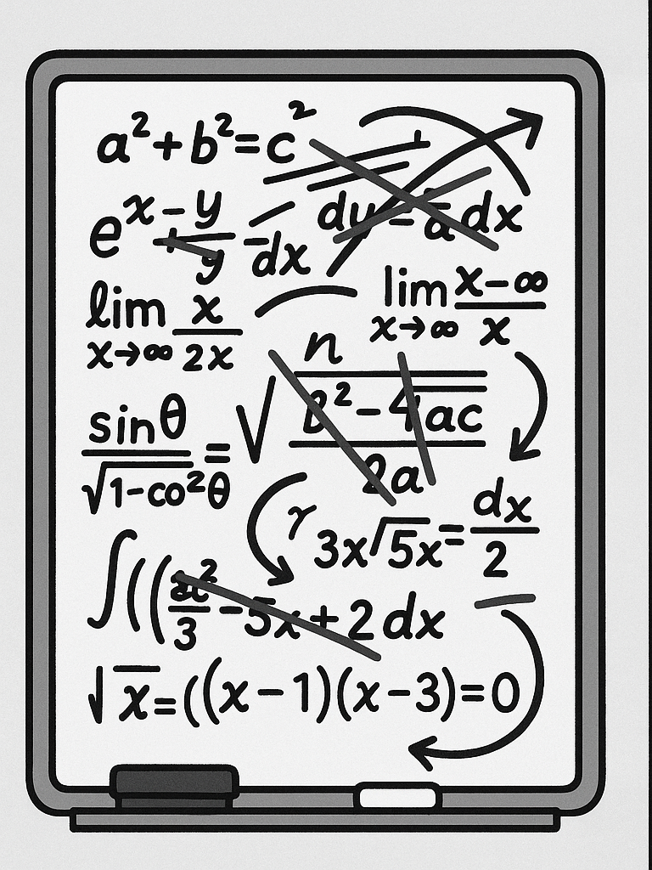 Scribbling 10 problems at once = No room for solutions

### ✅ The Step-by-Step Approach

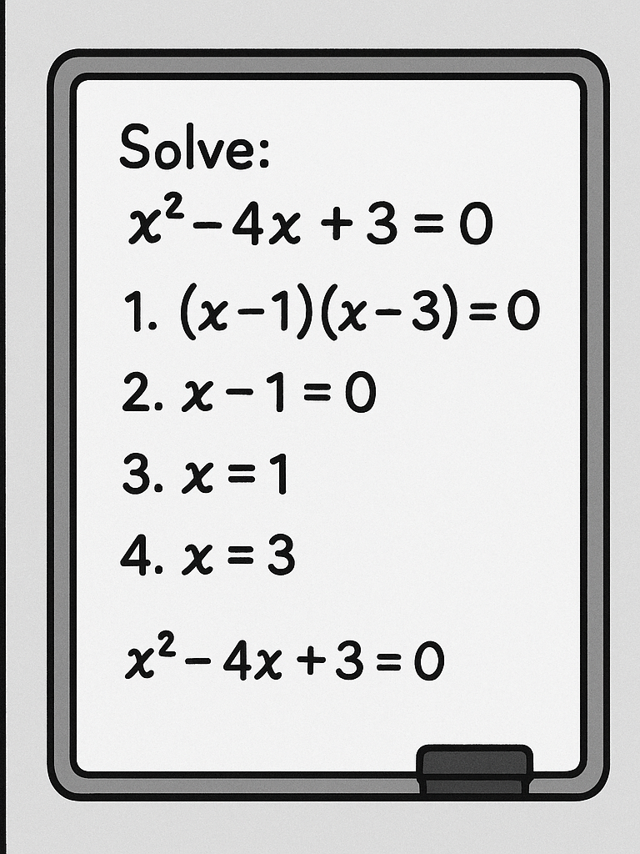 One problem, full space = Detailed, accurate results

**Takeaway:** A single, focused task gets the AI’s full attention

LLMs have a context window - think of it as their working memory. When you fill it with multiple complex tasks, each gets less attention and processing power.

# Technical Detail: Context Windows 📊

## What’s really happening?

* LLMs have **finite context windows** (8k-200k tokens)
* Token ≈ 0.75 words
* Each task competes for this limited space

## Example:

* LLM Context window: ~8,000 tokens
* Complex research prompt: ~500 tokens
* Response space needed: ~1,500 tokens per task
* **Result:** Only 3-4 tasks fit properly!

**Think of it like RAM:** Too many programs = computer slows down. Too many tasks = AI quality drops.

This is why breaking tasks down isn’t just helpful - it’s technically necessary for quality outputs.

# Reason 2: Guiding the AI’s “Thinking” 🧭

## LLMs Create Answers Piece by Piece

* Each word depends on previous words
* Complex prompts = mental shortcuts
* Structured prompts = logical reasoning

## Cooking Analogy 👨‍🍳

**❌ Bad:** “Make beef wellington”

*Chef might skip steps or use wrong ingredients*

**✅ Good:** 1. “First, sear the beef” 2. “Next, prepare duxelles” 3. “Then, wrap in pastry”

By giving step-by-step instructions, you force the AI to build a logical argument, leading to much stronger outputs.

# Reason 3: Easy Error Detection & Fixing 🔧

### With a Giant Prompt

* Problem: Weak experimental method
* Solution: Re-run EVERYTHING
* Time lost: 10-15 minutes
* Quality: Hope for the best 🤞

### With Our Workflow

* Problem: Weak experimental method
* Solution: Fix just that step
* Time lost: 2 minutes
* Quality: Keep what works ✓

**Benefit:** Iterative refinement = Higher quality + Less frustration

# Reason 4: More and Better Ideas 💡

## Diversity vs. Convergence

### ❌ Single Prompt Approach

“Give me the best hypothesis for oat milk fermentation” → **One idea, possibly mediocre**

### ✅ Our Multi-Step Approach

1. **Generate:** “Give me 5 hypotheses” → **Diversity**
2. **Evaluate:** “Score each for feasibility” → **Analysis**
3. **Select:** “Recommend the top 3” → **Quality**

**Result:** Multiple perspectives + Critical evaluation = Stronger research

# Good AI Outputs Look Like This:

**✅ Structure & Detail** - Organized sections - Specific numbers/examples - Academic language - Proper formatting

**✅ Actionable Content** - Clear next steps - Testable hypotheses - Realistic timelines - Measurable outcomes

# Bad AI Outputs Look Like This:

**❌ Vague & Generic** - “Consider various factors…” - “This is an important topic…” - “Results may vary…”

**❌ Incomplete** - Missing key sections - No specific examples - Unclear methodology

# The 10-Step Research Workflow 🔬

*From Idea to Manuscript*

**Discovery Phase (Steps 1-5)** ⏱️ *~60 minutes* 1. **Idea Generation** - Brainstorm hypotheses *(8 min)* 2. **Parallel Exploration** - Diversify ideas *(12 min)* 3. **Preliminary Testing** - Feasibility checks *(10 min)* 4. **Optimization** - Find best parameters *(15 min)* 5. **Full Execution** - Main study design *(15 min)*

# The 10-Step Research Workflow (cont’d) 📝

*From Idea to Manuscript*

**Communication Phase (Steps 6-10)** ⏱️ *~40 minutes*

1. **Component Analysis** - What matters most? *(8 min)*
2. **Visualization** - Create figures & charts *(10 min)*
3. **Writing** - Draft manuscript *(12 min)*
4. **Review** - Peer review simulation *(5 min)*
5. **Iteration** - Continuous improvement *(5 min)*

**Total time:** ~100 minutes for a complete research project from idea to first draft!

This mirrors the **actual scientific method** - we’re just using AI as our assistant!

# Step 1: Idea Generation 🌱

## The Power of Structured Brainstorming

**Prompt Template:**

You are an AI research scientist specializing in Food Science.  
Given the following research area, generate 5 distinct and   
innovative scientific hypotheses suitable for a Masters-level   
research paper.  
  
For each hypothesis, include:  
- A clear Title  
- 3-5 Keywords  
- A short Abstract (under 200 words)  
- An explanation of its Novelty and Significance  
  
Research Area: [YOUR TOPIC HERE]

**Pro tip:** Replace “Food Science” with your specific field for better results!

Notice how specific this prompt is. We’re not just asking for “ideas” - we’re asking for structured, academic hypotheses.

# Step 2-3: Exploration & Feasibility 🔍

## Step 2: Parallel Exploration *(12 min)*

* Open multiple chat sessions
* Generate non-overlapping ideas
* Score and rank all options
* **Output:** 10-15 diverse hypotheses

## Step 3: Preliminary Testing *(10 min)*

* Select top hypothesis
* Design minimal experiment
* Generate expected data
* **Output:** Feasibility confirmed

**Key insight:** Step 2 prevents tunnel vision - you see ALL possibilities before committing!

# Steps 4-6: The Research Core 🔬

## Building Your Study

**Step 4: Optimization** *(15 min)* - Test variable combinations - Define success criteria - Find the “sweet spot”

**Step 5: Full Execution** *(15 min)* - Detailed methodology - Comprehensive data tables - Statistical measures

**Step 6: Component Analysis** *(8 min)* - What ingredients matter? - Ablation studies - Understanding mechanisms

# Steps 7-10: Communication & Refinement 📊

**Step 7: Visualization** *(10 min)* - Generate scientific figures - Write clear captions - Visual storytelling

**Step 8: Manuscript Writing** *(12 min)* - Complete paper draft - All sections included - Proper citations

**Step 9: Peer Review** *(5 min)* - Critical evaluation - Scoring rubric - Actionable feedback

**Step 10: Iteration** *(5 min)* - Address weaknesses - Refine sections - Achieve excellence

# When AI Goes Wrong: Real Examples 🚨

## Hallucination Alert!

**Made-up Citations:** > “According to Smith et al. (2023), fermentation at 45°C increases yield by 23%”

**Reality:** Paper doesn’t exist!

**Plausible but Wrong Data:** > “Oat milk contains 15g protein per 100ml”

**Reality:** Usually 1-3g per 100ml

# What You Should Do:

1. **Always verify** numerical claims
2. **Check citations** before using them
3. **Cross-reference** with reliable sources
4. **Use AI for structure**, not facts

**Remember:** AI is confident even when wrong!

# Ethical Guidelines: Using AI in Academic Work 📜

## The Right Way to Cite AI Assistance

**In your methods section:** > “Hypothesis generation and experimental design were developed with assistance from Microsoft Copilot (Microsoft Corporation, 2024). All outputs were verified against peer-reviewed literature.”

## What Requires Citation:

* ✅ Idea generation
* ✅ Statistical analysis suggestions
* ✅ Writing structure
* ✅ Data interpretation ideas

## What Doesn’t:

* Grammar checking
* Simple calculations
* Basic formatting

**Bottom line:** When in doubt, cite it. Transparency builds trust.

# Live Demo Time! 🚀

## Your Choice: Which Research Should We Explore?

**Option A: 🥛 Fermentation Study** - Oat milk fermentation - pH, cell counts, viscosity - 3 treatments over 48 hours

**Option B: 📅 Shelf Life Analysis** - Yogurt alternatives - Microbial & sensory data - 4 products over 30 days

**Option C: 👅 Sensory Panel** - Plant-based cheese - 50 panelists - Texture, flavor, preference

**Option D: 🧪 Process Optimization** - Protein extraction yields - Temperature vs pH effects - Response surface data

# 🗳️ Vote Now!

Scan QR code or shout out your choice!

# Quick Demo: Bad vs. Good Prompting 🎯

## Let’s try both approaches… *(10 minutes total)*

### First: The “Everything” Prompt *(3 min)*

*Watch what happens when we ask for too much at once*

“Analyze [winning dataset], create graphs, write conclusions, and suggest future research”

### Then: Our Structured Approach *(7 min)*

*See the difference when we break it down*

Steps 1 → 3 → 7 in sequence

**Pay attention to:** Response quality, detail level, and actionability

# Troubleshooting Common Issues 🔧

## When Things Don’t Work

**Problem:** AI gives generic responses - **Solution:** Add more specific requirements to your prompt

**Problem:** Getting confused by long conversations - **Solution:** Start a new chat session

**Problem:** AI refuses to help - **Solution:** Rephrase more academically, avoid trigger words

**Universal fix:** When stuck, start fresh with a clearer, more specific prompt

# Understanding AI Limitations ⚠️

## Critical Things to Know

**Hallucinations** - AI can “make up” information - Fake citations are common - Always verify sources - May invent plausible-sounding data

**Other Limitations** - Knowledge cutoff dates - Can’t access real databases - No actual lab work - Context window limits

# Golden Rule for Research

**Never trust, always verify!** Use AI for ideation and structure, but validate all facts, citations, and data.

# Key Takeaways 🎓

1. **One Task, One Prompt** - Your golden rule
2. **Structure = Success** - Guide the AI step-by-step
3. **Iterate & Refine** - Fix what needs fixing
4. **Think Like a Manager** - You’re the boss!
5. **Always Verify** - AI assists, you validate

## Next Session Preview 👀

* Hands-on practice with all 10 steps
* Building your own AI research agent
* Advanced techniques and shortcuts
* **Bring a research topic you’re curious about!**

# Your Mission (Should You Choose to Accept) 🎯

## Before Next Session:

1. **Think** of a research topic you’re interested in
2. **Try** the idea generation prompt on your own
3. **Note** what works and what doesn’t
4. **Bookmark** copilot.microsoft.com or your preferred AI tool

# Remember

You’re not learning to use AI - you’re learning to **manage** AI

# Questions? 🤔

## Let’s Discuss!

* Concerns about the workflow?
* Technical questions?
* Want to see another demo?
* Ethical considerations?

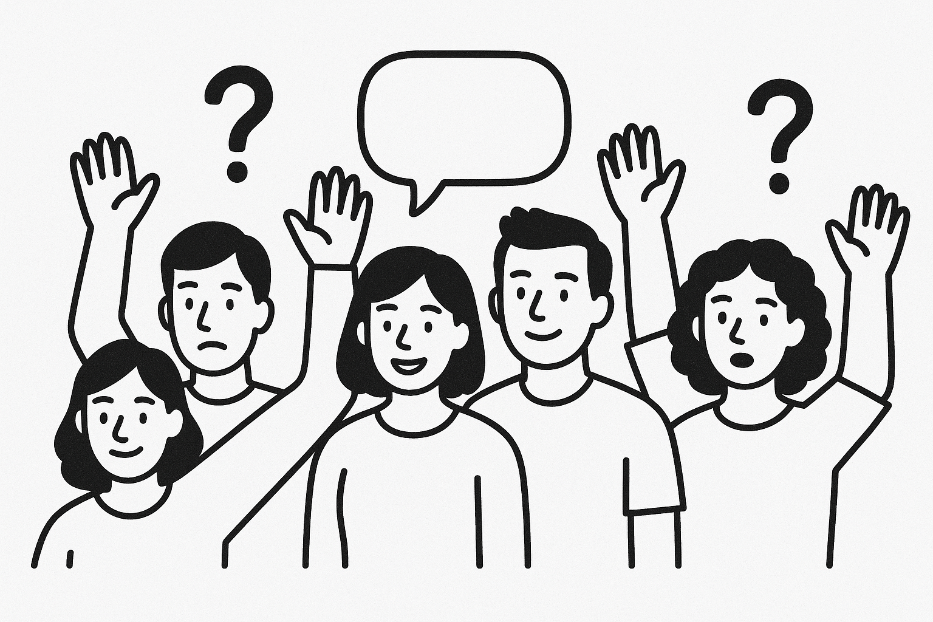

## 📧 Contact: michael.borck@curtin.edu.au

# Bonus Slide: The Complete Workflow 📋

## Your Research Assistant Checklist

| Step | Task | Time | Output |
| --- | --- | --- | --- |
| 1 | Idea Generation | 8 min | 5 hypotheses table |
| 2 | Parallel Exploration | 12 min | 10-15 total ideas |
| 3 | Feasibility Testing | 10 min | Experimental plan + data |
| 4 | Optimization | 15 min | Best parameters |
| 5 | Full Study | 15 min | Complete methodology |
| 6 | Component Analysis | 8 min | Key factors identified |
| 7 | Visualization | 10 min | Figures + captions |
| 8 | Writing | 12 min | Full paper draft |
| 9 | Review | 5 min | Feedback report |
| 10 | Iteration | 5 min | Refined manuscript |

This is a reference slide students can photograph or refer back to.

# Resources & Links 📚

## Everything You Need

* **Presentation slides:** [GitHub link will be here]
* **All datasets:** [GitHub data folder link]
* **Audio version:** [NotebookLM podcast link]
* **Video explainer:** [NotebookLM video link]
* **Quick reference:** [Prompt templates document]

**Created with assistance from Claude (Anthropic)**